**Project Report**

1. **INTRODUCTION** 
   1. Project Overview
   2. Purpose
2. **IDEATION PHASE**
   1. Problem Statement
   2. Empathy Map Canvas
   3. Brainstorming
3. **REQUIREMENT ANALYSIS**
   1. Customer Journey map
   2. Solution Requirement
   3. Data Flow Diagram
   4. Technology Stack
4. **PROJECT DESIGN** 
   1. Problem Solution Fit
   2. Proposed Solution
   3. Solution Architecture
5. **PROJECT PLANNING & SCHEDULING** 
   1. Project Planning
6. **FUNCTIONAL AND PERFORMANCE TESTING** 
   1. Performance Testing
7. **RESULTS** 
   1. Output Screenshots
8. **ADVANTAGES & DISADVANTAGES**
9. **CONCLUSION**
10. **FUTURE SCOPE**
11. **11. APPENDIX**

Source Code(if any)

Dataset Link

GitHub & Project Demo Link

**Team Members :**

Ayush Gupta (22BCE10279)

Mayank Kandpal (22BCE10518)

Ansh Khanna ( 22BCE11144 )  
Aditya Jain (22BAI10198)

**Project Report: Musicify**

**1 Introduction**

**1.1 Project Overview**

MusicifyMusicify is a comprehensive music streaming platform built using the MERN (MongoDB, Express.js, React, Node.js) stack. The platform creates a seamless experience for music enthusiasts to discover, explore, and listen to music from various genres and artists.

The application features a multi-role system with distinct user types:

* **Regular Users (Listeners)**: Can browse the music catalog, create accounts, create playlists, follow artists, and listen to music with both free and premium tiers
* **Artist Users**: Have access to a specialized dashboard for uploading and managing their music, tracking listener statistics, and interacting with fans
* **Admin Users**: Maintain the platform, manage users, and monitor content

The project integrates Firebase for authentication and MongoDB Atlas for database management, creating a robust and scalable infrastructure. The responsive design ensures a consistent experience across desktop and mobile devices, allowing users to enjoy music anytime and anywhere. The application includes features like continuous playback, personalized playlists, and algorithmic recommendations.

**1.2 Purpose**

The primary purpose of Musicify is to create an accessible and user-friendly platform connecting music lovers with their favorite tracks while providing artists with efficient management tools and listener insights.

The key objectives of the Musicify project are:

* **Enhanced Music Discovery** – Provide algorithmic recommendations, curated playlists, and radio functionality to help users discover music matching their interests
* **Seamless Listening Experience** – Enable efficient browsing, searching, playlist creation, and a streamlined playback process with queue management
* **User Account Management** – Allow listeners to create profiles with both free and premium tiers, track listening history, save favorite songs, and manage personal information securely
* **Artist Management System** – Equip artists with tools to easily upload, update, and organize their music catalog, as well as monitor listener statistics
* **Security & Authentication** – Implement Firebase authentication alongside secure data handling practices to protect user information and prevent unauthorized access
* **Responsive & Intuitive UI** – Create a visually appealing, easy-to-navigate interface with dark mode that works seamlessly across all devices
* **Database Optimization** – Utilize MongoDB Atlas for efficient data storage and retrieval, ensuring fast performance even with large music catalogs and user bases
* **Streaming Architecture** – Develop robust backend systems to handle audio streaming, playlists, and user activity tracking
* **Scalable Architecture** – Build a well-structured application using the MERN stack that can easily accommodate growing catalogs, increasing user traffic, and additional features

**2 Ideation Phase**

| **Date** | **27 March 2025** |
| --- | --- |
| **Team ID** | **SWTID1744391109** |
| **Project Title:** | **Musicify** |
| **Maximum Marks** | **2 Marks** |

**2.1 Customer Problem Statement Template:**

Create a problem statement to understand our customers' point of view. The Customer Problem Statement template helps you focus on what matters to create experiences people will love.

A well-articulated customer problem statement allows you and your team to find the ideal solution for the challenges your customers face. Throughout the process, you’ll also be able to empathize with your customers, which helps you better understand how they perceive your product or service.

**Example:**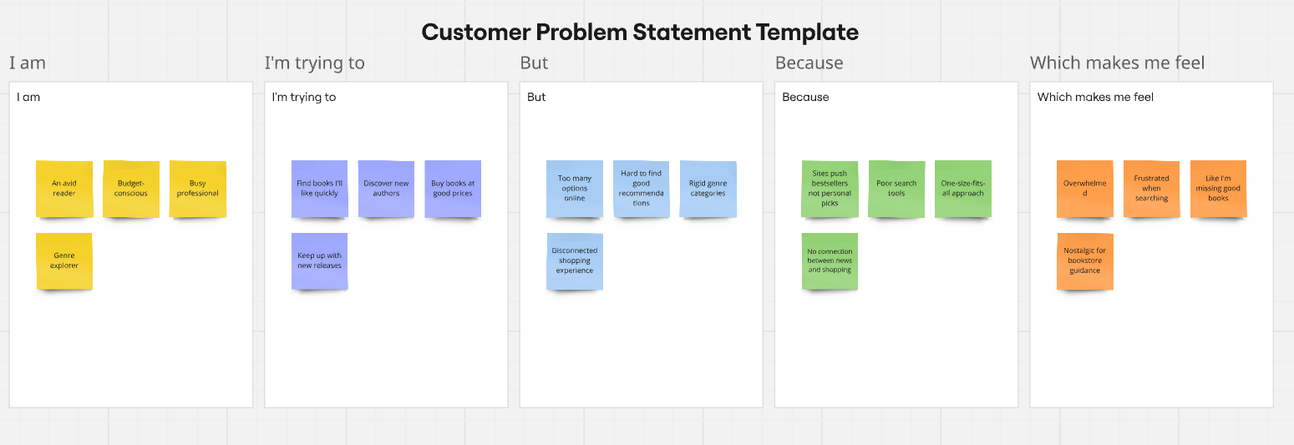

| **Problem Statement (PS)** | **I am (Customer)** | **I’m trying to** | **But** | **Because** | **Which makes me feel** |
| --- | --- | --- | --- | --- | --- |
| PS-1 | A music enthusiast | Discover new artists and songs | Most platforms have limited discovery options | Algorithms tend to repeat similar recommendations | Stuck in a music bubble |
| PS-2 | Budget-conscious listener | Listen to high-quality music | Many platforms require premium subscriptions | Free tiers have intrusive ads and limitations | Frustrated with interruptions |
| PS-3 | Independent artist | Share my music with potential fans | Getting visibility is extremely difficult | Major labels dominate promotional slots | Overlooked and undervalued |
| PS- 4 | On-the-go listener | Seamlessly transition between devices | My listening state doesn't sync well | Platform limitations in cross-device experience | Disconnected and annoyed |

**2.2 Empathy Map Canvas:**

An empathy map is a simple, easy-to-digest visual that captures knowledge about a user’s behaviours and attitudes.

It is a useful tool to helps teams better understand their users.

Creating an effective solution requires understanding the true problem and the person who is experiencing it. The exercise of creating the map helps participants consider things from the user’s perspective along with his or her goals and challenges.

**Example: Our Project on Full stack Music Streaming Platform- Musicify**

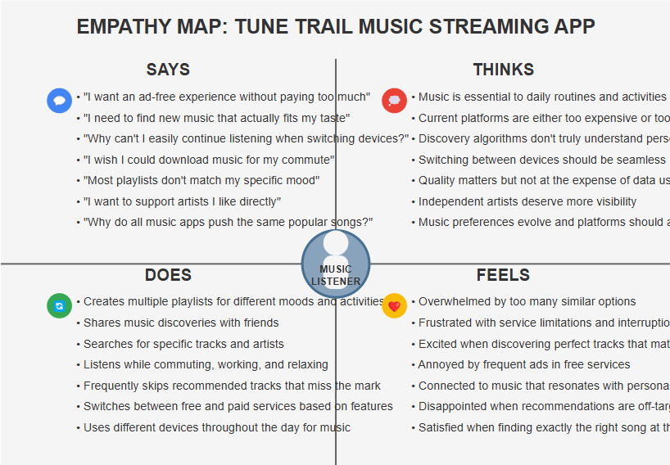

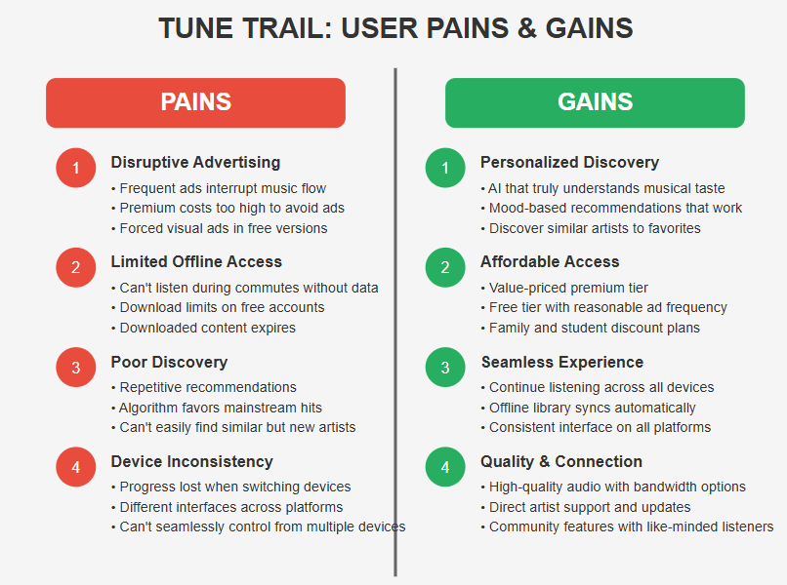

**2.3 Brainstorm & Idea Prioritization :**

**Step-1: Team Gathering, Collaboration and Select the Problem Statement**

* Team identified the core problem: "Music streaming platforms fail to balance affordability, discovery, and seamless experience"
* Focus on creating a service that addresses these three key pain points simultaneously

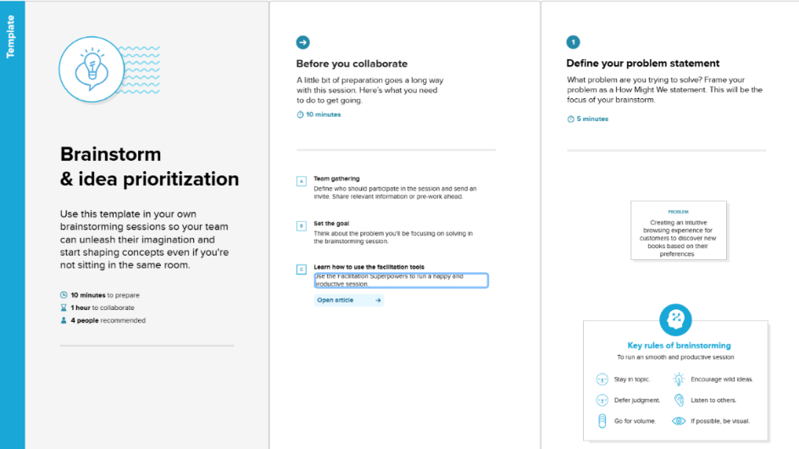

**Step-2: Brainstorm, Idea Listing and Grouping**

* **Affordability Ideas**: Tiered pricing, ad-supported free tier with reasonable limits, student/family plans
* **Discovery Ideas**: Advanced algorithm using listening habits, mood detection, playlist radio, genre exploration
* **Experience Ideas**: Cross-device syncing, offline mode, background play, queue management, high-quality audio options
* **Differentiation Ideas**: Lyric integration, song information, artist insights, visualization features

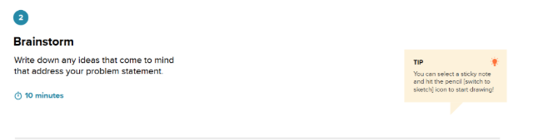

**Step-3: Idea Prioritization**

* **High Impact/Low Effort**: Cross-device listening state sync, basic recommendation engine, playlist management
* **High Impact/High Effort**: Advanced discovery algorithm, offline mode, premium tier infrastructure
* **Low Impact/Low Effort**: Basic user profiles, dark/light themes, sharing capabilities
* **Low Impact/High Effort**: Visualization features, social network integration, lyrics synchronization

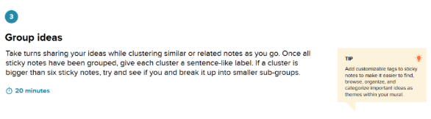

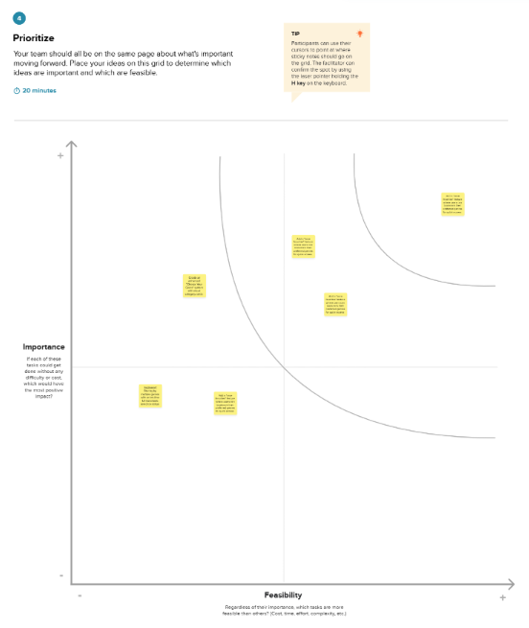

**3 REQUIREMENT ANALYSIS**

| Date | **30 March 2025** |
| --- | --- |
| Team ID | **SWTID1744391109** |
| Project Title | **Musicify** |
| Maximum Marks | **4 Marks** |

**3.1 Customer Journey Map:**

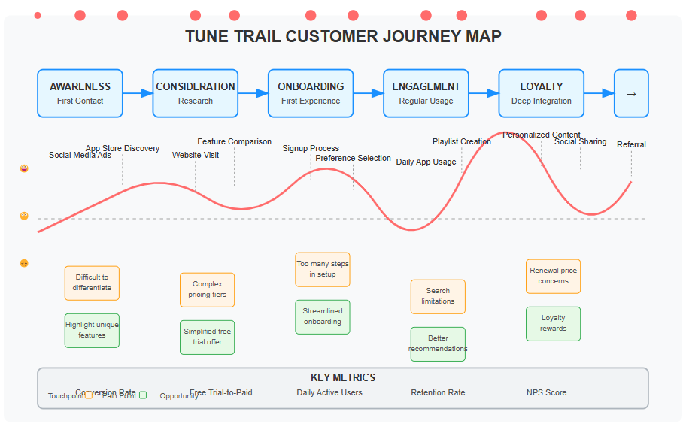

**3.2 Solution Requirements (Functional & Non-functional)**

**Functional Requirements:**

The following are the functional requirements of the proposed solution.

| **FR No.** | **Functional Requirement (Epic)** | **Sub Requirement (Story / Sub-Task)** |
| --- | --- | --- |
| FR-1 | User Registration & Authentication | Registration through Form, Social Login Integration, Role selection (Listener, Artist, Admin), Free/Premium tier selection |
| FR-2 | Music Playback & Control | Play/Pause/Skip Controls, Volume Control, Queue Management, Continuous Playback, Background Playing |
| FR-3 | | Role-Based Dashboard Access | | --- | | Admin: Content Moderation & Statistics, Artist: Upload & Analytics, Listener: Personalized Home & Library |
| FR-4 | Music Discovery | Search functionality, Browse categories, New releases section, Algorithmic recommendations |
| FR-5 | Playlist & Library Management | Create/Edit/Delete Playlists, Add/Remove Tracks, Like Songs, Follow Artists |
| FR-6 | Personalized Experience | Weekly Discovery Playlist, Recently Played, Favorite Artists Updates, For You Section |

**Non-functional Requirements:**

The following are the non-functional requirements of the proposed solution.

| **FR No.** | **Non-Functional Requirement** | **Description** |
| --- | --- | --- |
| NFR-1 | **Usability** | Intuitive UI with dark theme, mobile responsiveness, and accessibility features |
| NFR-2 | **Security** | Firebase Auth, token-based API security, secure payment processing |
| NFR-3 | **Reliability** | 99.9% uptime guarantee with failover systems and data backups |
| NFR-4 | **Performance** | Fast stream initialization (<2s), minimal buffering, efficient API responses |
| NFR-5 | **Availability** | |  | | --- |  | Cloud-hosted infrastructure with load balancing and geographic distribution | | --- | |
| NFR-6 | **Scalability** | Microservice architecture capable of handling millions of concurrent streams |

**3.3 Data Flow Diagrams:**

A Data Flow Diagram (DFD) is a traditional visual representation of the information flows within a system. A neat and clear DFD can depict the right amount of the system requirement graphically. It shows how data enters and leaves the system, what changes the information, and where data is stored.

**Example:** [**(Simplified)**](https://developer.ibm.com/patterns/visualize-unstructured-text/)

**Flow Sequence:**





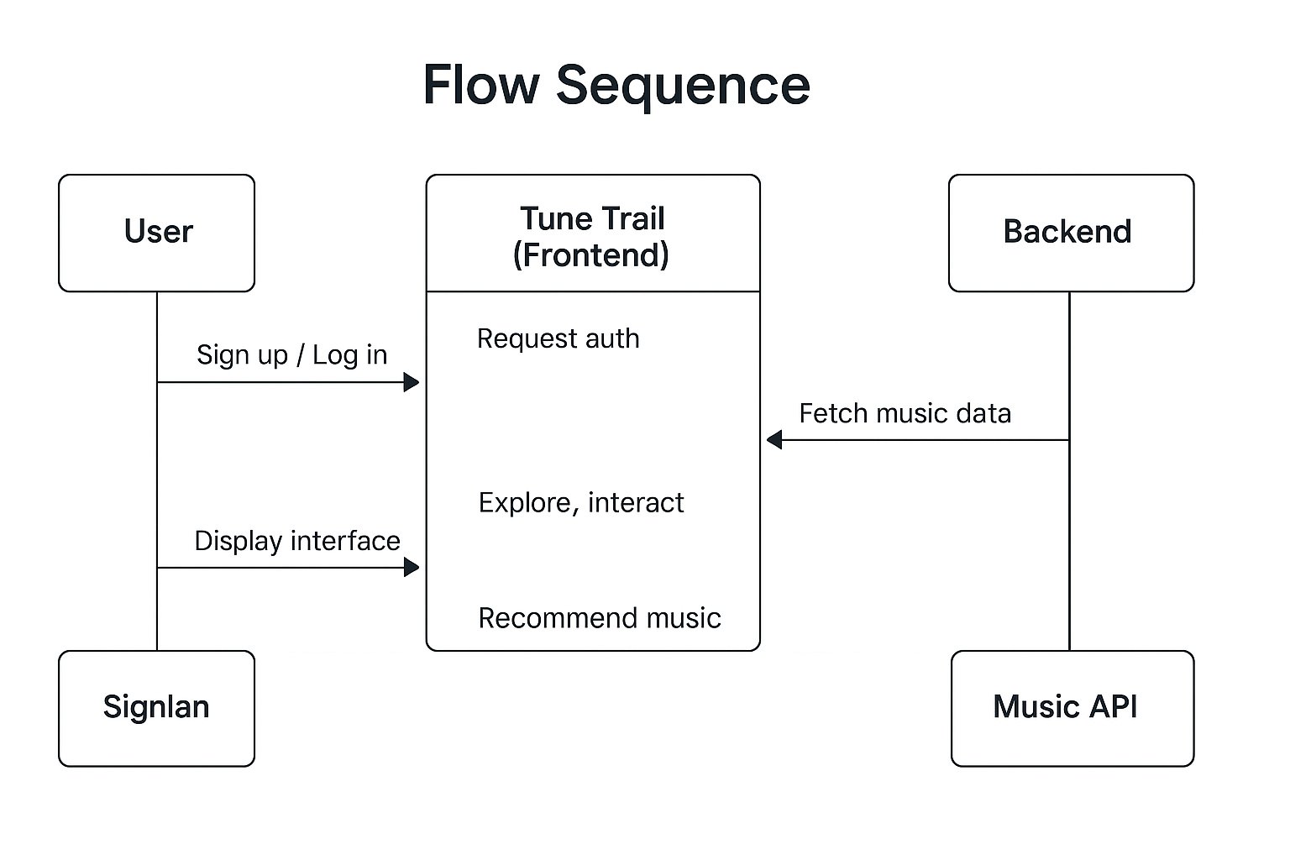

**User Stories:**

| **User Type** | **Functional Requirement (Epic)** | **User Story Number** | **User Story / Task** | **Acceptance Criteria** | **Priority** | **Release** |
| --- | --- | --- | --- | --- | --- | --- |
| Listener | Registration | USN-1 | As a listener, I can create an account and select my music preferences | I can successfully register and see personalized content | High | Sprint-1 |
| Listener | Music Playback | USN-2 | As a listener, I can play music with standard controls | I can play/pause/skip tracks and adjust volume | High | Sprint-1 |
| Listener | Playlist Management | USN-3 | As a listener, I can create and manage playlists | I can create, edit, and delete playlists | High | Sprint-1 |
| Listener | Discovery | USN-4 | As a listener, I can browse music by genres, moods, and activities | I can navigate categories and find relevant music | Medium | Sprint-2 |
| Listener | Premium Features | USN-5 | As a premium listener, I can download music for offline listening | I can access downloaded music without internet connection | Medium | Sprint-2 |
| Listener | Cross-device | USN-6 | As a listener, I can continue playback across multiple devices | My playback state syncs when I switch devices | High | Sprint-2 |
| Artist | Registration | USN-7 | As an artist, I can create an artist account | I can access artist-specific features after verification | High | Sprint-1 |
| Artist | Music Upload | USN-8 | As an artist, I can upload and manage my music | I can add, edit, and remove my tracks from the platform | High | Sprint-1 |
| Artist | Analytics | USN-9 | As an artist, I can view listener statistics for my music | I can see play counts, geographic data, and listener demographics | Medium | Sprint-2 |
| Admin | User Management | USN-10 | As an admin, I can manage user accounts | I can view, edit, and deactivate user accounts when necessary | High | Sprint-1 |
| Admin | Content Moderation | USN-11 | As an admin, I can review and moderate uploaded content | I can approve, reject, or flag content for review | Medium | Sprint-2 |
| Admin | Platform Monitoring | USN-12 | As an admin, I can view system performance metrics | I can access dashboards showing usage statistics and performance data | Low | Sprint-3 |

**3.4 Technical Architecture:**

**Table-1 : Components & Technologies:**

| **S.No** | **Component** | **Description** | **Technology** |
| --- | --- | --- | --- |
| 1. | User Interface | Web-based responsive interface with dark theme | React.js, Tailwind CSS |
| 2. | Authentication Service | Handles user registration, login, and session management | Firebase Authentication, JWT |
| 3. | Streaming Service | Manages audio delivery and playback | Node.js, Express.js, Web Audio API |
| 4. | Discovery Service | Handles recommendations and browsing functionality | Node.js, Express.js, Machine Learning algorithms |
| 5. | User Management Service | Manages user profiles, preferences, and subscription status | Node.js, Express.js |
| 6. | Database | Stores user profiles, music metadata, playlists, listening history | MongoDB (NoSQL) |
| 7. | File Storage | Stores music files and related media | AWS S3 / Firebase Storage |
| 8. | Cloud Database | Cloud-hosted database instance | MongoDB Atlas |
| 9. | Payment Processing | Handles premium subscription transactions | Stripe / PayPal integration |
| 10. | Infrastructure (Server/Cloud) | Cloud-hosted platform with load balancing | AWS / Google Cloud / Azure |

**Table 2: Application Characteristics:**

| **S.No** | **Characteristics** | **Description** | **Technology** |
| --- | --- | --- | --- |
| 1. | Open-Source Frameworks | Modern web technologies for scalable application development | MERN Stack, Web Audio API |
| 2. | Security Implementations | Multi-layer security approach | HTTPS, OAuth 2.0, JWT, Content Encryption |
| 3. | Scalable Architecture | Microservice design for independent scaling of components | Docker, Kubernetes, Load Balancing |
| 4. | Availability | Redundant systems with automatic failover | Multi-region deployment, Health monitoring |
| 5. | Performance | Efficient streaming and caching strategies | CDN integration, Progressive loading, Audio compression |

**4 Project Design Phase**

| Date | 01 April 2025 |
| --- | --- |
| Team ID | **SWTID1744391109** |
| Project Title | Musicify - A MERN Music Streaming App |
| Maximum Marks | 2 Marks |

**4.1 Problem – Solution Fit:**

* With the exponential growth of online music streaming platforms, users today are presented with an overwhelming amount of content. Platforms like Spotify, Apple Music, and YouTube Music host millions of tracks, but most users only engage with a small fraction of this content. The challenge lies not in the availability of music, but in meaningful **music discovery** — finding new tracks that resonate with personal taste without relying solely on generic algorithmic suggestions.
* Moreover, users lack a **visually rich representation of their listening history**, a way to understand their musical evolution, and tools that foster engagement beyond passive consumption. Current systems offer “for you” sections or limited data summaries, but these often fall short in personalization, interaction, and long-term engagement.
* **Musicify** addresses these issues by acting as a **music discovery and visualization tool** that not only recommends music based on user behavior but also visualizes the user's listening patterns as an interactive journey. It provides a more holistic and immersive experience that brings clarity to musical preferences, connects users with emerging artists, and makes music exploration a visually engaging and emotionally satisfying experience.

**4.2 Proposed Solution**

Project team shall fill the following information in the proposed solution template.

| **S.No.** | **Parameter** | **Description** |
| --- | --- | --- |
| 1 | Problem Statement (Problem to be solved) | Users face **choice overload** with countless music options and struggle with discovering new music tailored to their taste. Existing platforms offer limited personalization and lack meaningful visual tools to track and understand listening behaviors.. |
| 2 | Idea / Solution Description | **Musicify** is an interactive music discovery platform that provides users with a **visual timeline** of their listening history, offering **personalized recommendations** based on individual preferences. The app combines an intuitive frontend, a powerful backend, and an admin panel for content management to create a unique music discovery experience. |
| 3 | Novelty / Uniqueness | Musicify stands out with its **interactive timeline** of user listening history, **personalized recommendations**, and **transparent recommendation logic**. Unlike traditional platforms, it offers users a **visual and self-reflective** way to discover and engage with music. |
| 4 | Social Impact / Customer Satisfaction | **Musicify** enhances customer satisfaction by helping users **connect emotionally** with music, discover new genres, and track their musical journey. It promotes **artistic diversity**, emotional well-being, and **personal growth** through music. |
| 5 | Business Model (Revenue Model) | The platform adopts a **freemium model** with revenue streams from:   * Premium subscriptions for advanced features. * Affiliate links to music services. * Sponsored playlists and custom merchandise. |
| 6 | Scalability of the Solution | The solution is **scalable** with:   * **Cloud infrastructure** for efficient resource management. * **Modular design** that allows independent scaling of components. * **API-first architecture** for easy third-party integration. |

**4.3 Solution Architecture:**

**Key Objectives:**

* **Role-Based Authentication**: Implement secure login/signup with Firebase, providing access control for Admin and Buyer roles.
* **Scalable Database**: Use MongoDB Atlas to store data on users, music tracks, playlists, and orders.
* **Personalized Music Experience**: Offer recommendations based on genres and user preferences, ensuring tailored content for each user.

**Core Components:**

* **Frontend**: React.js to manage dynamic UI based on user roles (Admin/Buyer).
* **Authentication**: Firebase for login/signup and user role management.
* **Backend API**: Node.js + Express for routing and business logic.
* **Database**: MongoDB Atlas for storing users, music tracks, playlists, and orders.
* **Recommendations Engine**: Personalized music recommendations based on user behavior and preferences.

**Solution Architecture Diagram:**

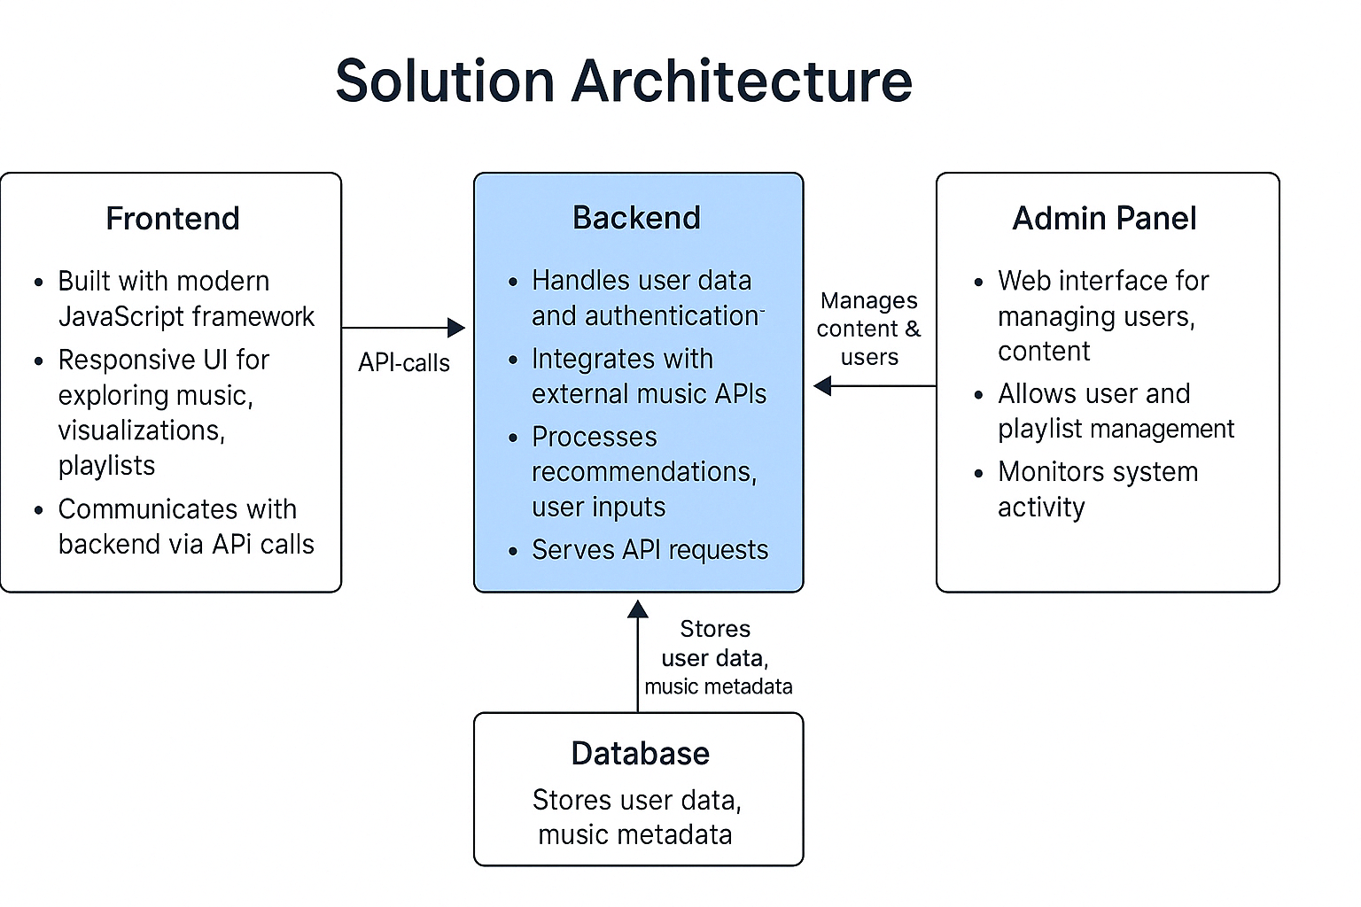

*Figure 1: Architecture and data flow of the website*

**5 PROJECT PLANNING AND SCHEDULING**

**5.1 Project planning**

| Date | **02 April 2025** |
| --- | --- |
| Team ID | **SWTID1744391109** |
| Project Title | **Music Streaming App** |
| Maximum Marks | **5 Marks** |

**Product Backlog, Sprint Schedule, and Estimation:**

| **Sprint** | **Functional Requirement (Epic)** | **User Story Number** | **User Story / Task** | **Story Points** | **Priority** | **Team Members** |
| --- | --- | --- | --- | --- | --- | --- |
| Sprint-1 | Registration | USN-1 | As a user, I can register by entering my email, password, and confirming my password. | 2 | High | **Mayank** |
| Sprint-1 | Confirmation | USN-2 | As a user, I receive a confirmation mail on registration. | 1 | High | **Mayank** |
| Sprint-2 | Registration | USN-3 | As a user, I can register using Facebook. | 2 | Low | **Aditya** |
| Sprint-1 | Registration | USN-4 | As a user, I can register using Gmail. | 2 | Medium | **Aditya** |
| Sprint-1 | Login | USN-5 | As a user, I can log in using email and password. | 1 | High | **Ayush** |
| Sprint-1 | Dashboard Setup | USN-6 | As a user, I can view a basic homepage / dashboard when I login. | 2 | High | **Ayush** |
| Sprint-1 | Navigation Functionality | USN-7 | As a user I can play/ pause and navigate between the songs. | 3 | High | **Ansh** |
| Sprint-1 | Favourites Functionality | USN-8 | As a user I can mark the songs as my favourite. | 3 | Medium | **Ansh** |
| Sprint-2 | Playlist Functionality | USN-9 | As a user I can create a playlist. | 3 | High | **Ayush** |
| Sprint-2 | Now Playing Function | USN-10 | As a user, I can view the current playing song. | 3 | High | **Mayank** |
| Sprint-2 | Add songs to queue | USN-11 | As a user I can add the songs to the queue. | 2 | Medium | **Aditya** |
| Sprint-2 | Add songs functionality | USN-12 | As a user, I can add new songs to the music player. | 3 | High | **Ansh** |

**Total Story Points: Sprint-1 = 14, Sprint-2 = 13**

**Project Tracker, Velocity & Burndown Chart: (4 Marks)**

| **Sprint** | **Total**  **Story Points** | **Duration** | **Sprint**  **Start Date** | **Sprint**  **End Date**  **(Planned)** | **Story**  **Points**  **completed** | **Sprint**  **Release Date**  **(Actual)** |
| --- | --- | --- | --- | --- | --- | --- |
| Sprint-1 | 14 | 5 Days | 1 April 2025 | 5 April 2025 | 14 | 6 April 2025 |
| Sprint-2 | 13 | 5 Days | 6 April 2025 | 10 April 2025 | 13 | 12 April 2025 |
| Sprint-3 | 20 | 5 Days | 11 April  2025 | 15 April 2025 | TBD | TBD |
|  |  |  |  |  |  |  |

**Velocity :**

* Total Story Points Completed (Sprint 1 + 2) = 14 + 13 = 27
* Total Sprints Completed = 2
* Velocity per Sprint = 27 / 2 = 13.5
* Average Velocity per Day = 13.5 / 6 ≈ 2.25 Story Points/day

**Burndown Chart:** 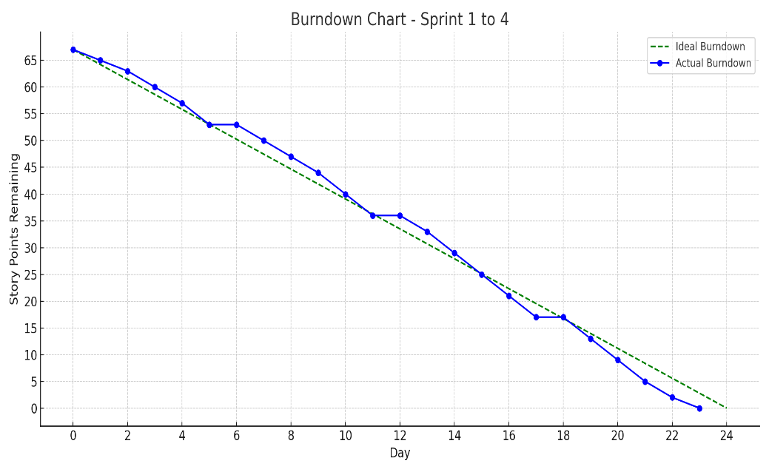

A burndown chart is a graphical representation of work left to do versus time. It is often used in agile[software development](https://www.visual-paradigm.com/scrum/what-is-agile-software-development/) methodologies such as [Scrum](https://www.visual-paradigm.com/scrum/scrum-in-3-minutes/). However, burn down charts can be applied to any project containing measurable.

**6 Functionality and Performance testing**

| Date | **13 April 2025** |
| --- | --- |
| Team ID | **SWTID1744391109** |
| Project Title | **Music Streaming App** |
| Maximum Marks | **10** |

**6.1 User Acceptance Testing (UAT)**

**Project Overview**

* **Project Name: MERN Music Streaming Platform**
* **Project Description:**A robust full-stack MERN (MongoDB, Express.js, React.js, Node.js) web application designed for music streaming. It offers database based authentication and MongoDB Atlas integration. The platform allows users to sign up/log in, play/pause/navigate songs, like or dislike tracks, and manage their personal playlists. Admins can upload songs and manage content through a dedicated dashboard. Users can create, delete, and populate playlists with their favorite tracks.
* **Project Version: 1.0.0**
* **Testing Period: April 13, 2025 – April 15, 2025**

**Testing Scope**

**Features and Functionalities to be Tested:**

* User authentication and session management
* Song play, pause, and navigation controls
* Playlist creation and deletion
* Adding/removing songs from playlists
* Like/dislike functionality for individual songs
* Admin dashboard for uploading/managing songs
* User dashboard with playlist and favorite song management
* Data consistency between client, backend, and MongoDB Atlas
* Responsive design compatibility across devices and browsers

**User Stories to be Validated:**

* Users can securely authenticate maintain session state
* Users can play, pause, and navigate through songs seamlessly
* Users can create, delete, and manage multiple playlists
* Users can like and dislike songs
* Admins can upload new songs using the dashboard
* Songs can be added to playlists and played from them
* All UI/UX flows match the intended design and usability expectations

**Testing Environment**

* Deployment URL: https://localhost:5173.com
* Tech Stack: React.js (frontend), Express.js & Node.js (backend), MongoDB Atlas (database)
* Credentials (if required):

Email: [user123@gmail.com](mailto:user123@gmail.com)  
Password: user123

**Test Cases**

| **Test Case ID** | **Test Scenario** | **Test Steps** | **Expected Result** | **Actual Result** | **Pass/Fail** |
| --- | --- | --- | --- | --- | --- |
| TC-001 | Authentication | 1. Navigate to login page  2. Enter valid credentials  3. Submit form | User is redirected to dashboard and session is maintained | Authentication failed | Fail |
| TC-002 | Play/Pause Music | 1. Click on a song  2. Press Play  3. Pause mid-way | Song plays and pauses as expected | Feature was working | Pass |
| TC-003 | Create Playlist | 1. Navigate to playlists2. Click “Create Playlist”3. Name and save | Playlist appears in user dashboard | Feature was working | Pass |
| TC-004 | Add Songs to Playlist | 1. Open a song2. Click “Add to Playlist”3. Choose playlist | Song is added to the selected Albumt | Feature was working | Pass |
| TC-005 | Like a Song | 1. Play a song2. Click on Like icon | Song is marked as liked | Feature was not working | Failed |
| TC-006 | Admin Song Upload | 1. Login as admin2. Upload song from dashboard | Song appears in music list | Feature was working | Passed |
| TC-007 | Playlist Deletion | 1. Navigate to user playlist2. Delete a playlist | Playlist is removed from UI and database | Feature was working | Passed |

**Bug Tracking**

| **Bug ID** | **Bug Description** | **Steps to Reproduce** | **Severity** | **Status** | **Additional Feedback** |
| --- | --- | --- | --- | --- | --- |
| BG-001 | Authentication not working | 1. Navigate to login page  2. Enter valid credentials  3. Click Login button | High | Open | Login form submits but no user is redirected |
| BG-002 | Like button not functioning | 1. Play a song  2. Click the Like button  3. Refresh page | Medium | In Progress | Like state not persisting or updating visually |
| BG-003 | Playlist not refreshing after song addition | 1. Add a song to playlist  2. Go back to dashboard  3. Playlist doesn't update | Medium | Open | Requires manual refresh to reflect changes |
| BG-004 | Music playback glitches during quick switching | 1. Rapidly click different songs in a row | Low | Open | Overlapping playback or delayed response |

**Notes:**

* Ensure that all test cases cover both positive and negative scenarios.
* Encourage testers to provide detailed feedback, including any suggestions for improvement.
* Bug tracking should include details such as severity, status, and steps to reproduce.
* Obtain sign-off from both the project manager and product owner before proceeding with deployment.

**7) Results**

**Output Screenshots:**

**Home Page:**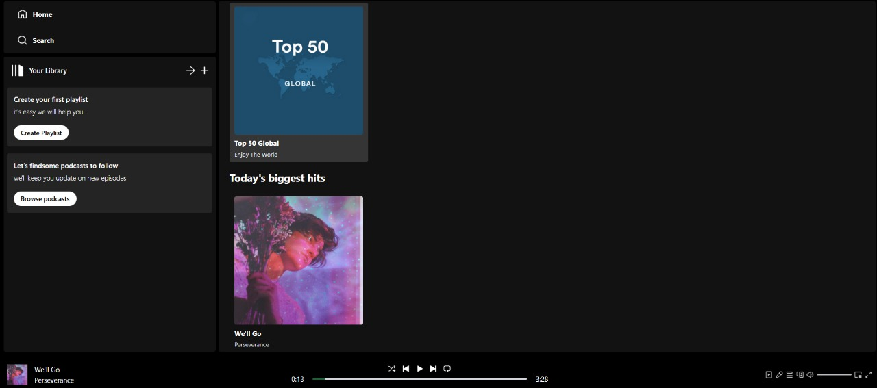

**Admin Panel:**

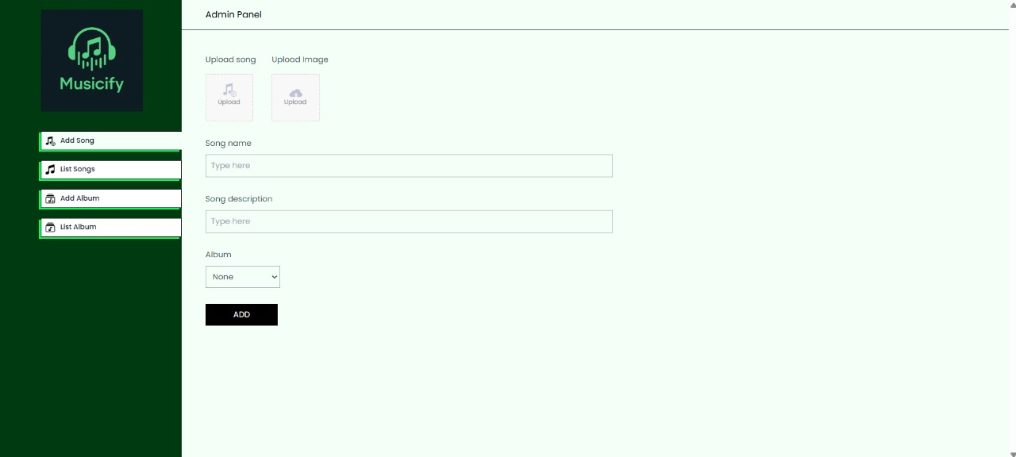

**Add Albums:**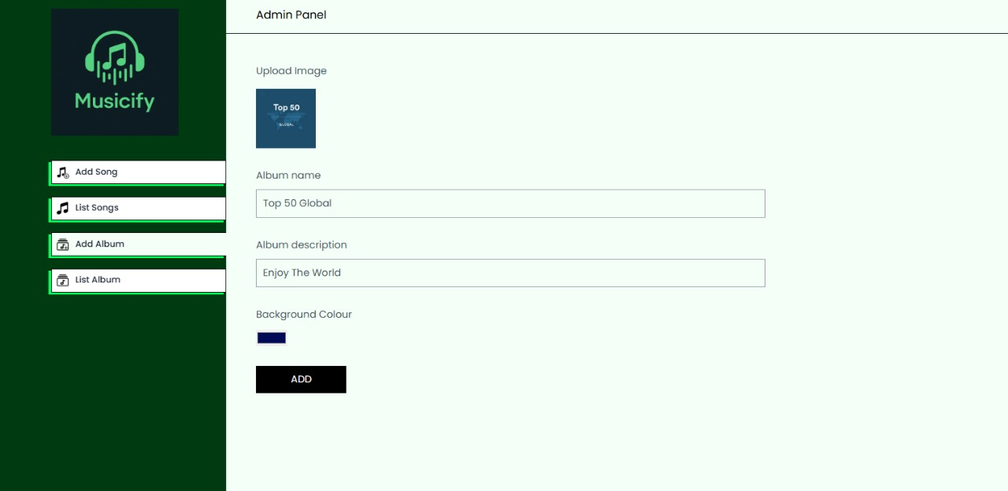

**Add Songs:**

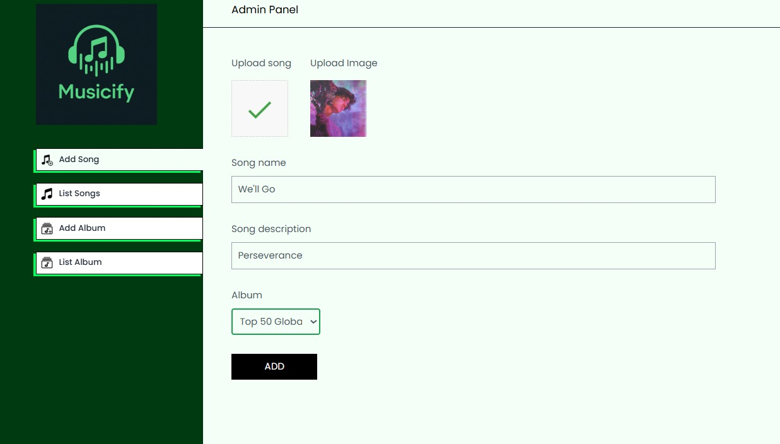

**Song List:**

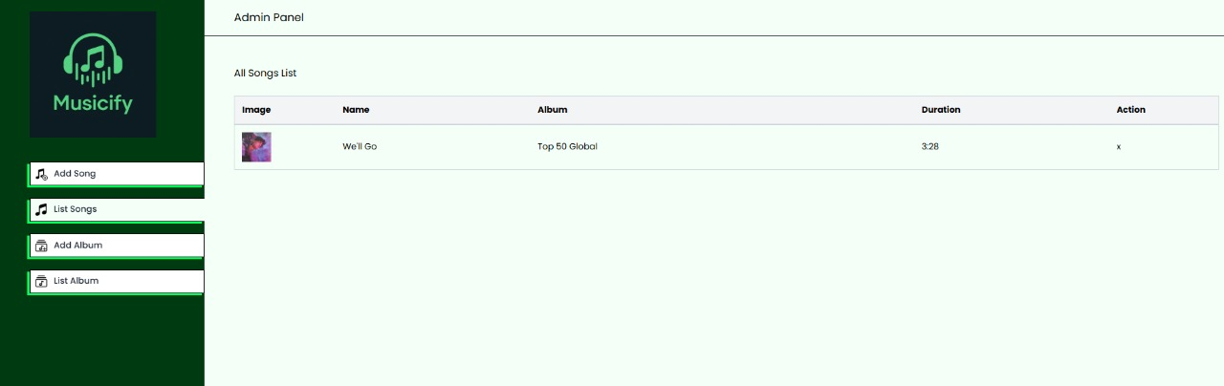

**Album List**

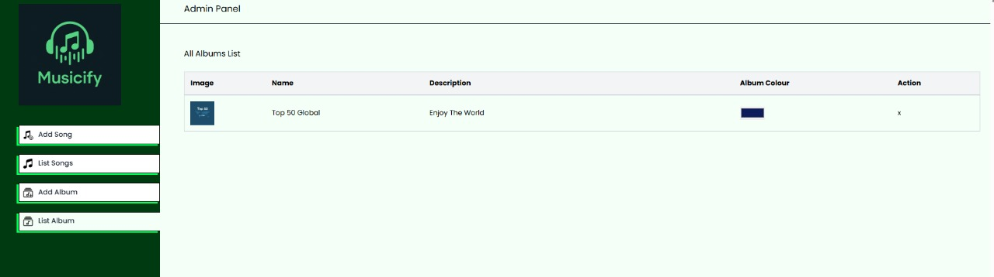

**8 ADVANTAGES AND DISADVANTAGES**

**Advantages:**

1. **Unified JavaScript Stack** - Using JavaScript throughout the entire application (MongoDB, Express, React, Node.js) simplifies development and allows for better team collaboration with a common language.
2. **Real-time User Experience** - MongoDB and React's virtual DOM enable efficient data handling and UI updates, creating a responsive experience for book browsing, cart management, and checkout.
3. **Scalability** - MongoDB Atlas provides cloud-based database scaling that can accommodate growing book catalogs and increasing user numbers without performance degradation.
4. **Authentication Security** - Firebase integration offers robust, production-ready authentication systems with features like social logins and multi-factor authentication without building these security components from scratch.
5. **Component Reusability** - React's component-based architecture allows for creating reusable UI elements (book cards, search filters, cart items) that maintain consistency while reducing development time.
6. **JSON Data Structure** - The MERN stack uses JSON format throughout, enabling seamless data transfer between frontend, backend, and database without format conversions.
7. **Rich Ecosystem** - Access to extensive libraries and tools from the Node.js and React communities provides solutions for common e-commerce features like payment processing, image handling, and search functionality.

**Disadvantages:**

1. **Learning Curve** - The MERN stack requires proficiency in multiple technologies, potentially extending development time for team members unfamiliar with all components.
2. **Performance Challenges** - JavaScript's single-threaded nature in Node.js can impact performance for CPU-intensive operations like complex search algorithms or large report generation.
3. **Security Considerations** - NoSQL databases like MongoDB require careful implementation of security practices as they lack the built-in security features of traditional relational databases.
4. **State Management Complexity** - As the application grows, managing state across numerous React components can become increasingly complex, potentially requiring additional libraries.
5. **MongoDB Limitations** - Complex transactions involving multiple collections (e.g., inventory updates with order processing) require careful implementation compared to SQL databases with native transaction support.
6. **Initial Setup Overhead** - Configuring the full stack environment, connecting services like Firebase and MongoDB Atlas, and establishing proper project structure requires significant initial investment.
7. **Version Compatibility** - Keeping all components of the MERN stack and their dependencies up-to-date without breaking changes can be challenging.

**9 Conclusion**

**Conclusion:**

**Musicify** reimagines the way users interact with music by bridging the gap between passive listening and active exploration. It tackles a common yet overlooked problem in music streaming: the lack of personalized, transparent, and emotionally resonant discovery experiences. By offering users an interactive timeline of their listening journey and intelligent recommendations drawn from their unique habits, Musicify turns music consumption into a reflective and engaging process.

The solution’s modular and scalable architecture ensures that it is not only effective today but also future-proof. It can adapt to evolving user needs, integrate additional features such as mood-based discovery or social sharing, and handle growing data volumes without compromising performance.

Beyond its technical strength, Musicify holds social value — encouraging diversity in music taste, supporting lesser-known artists through discovery, and fostering emotional wellness through musical self-reflection. Its flexible business model, combined with strong customer engagement potential, sets the foundation for long-term sustainability and impact.

In essence, Musicify is not just another music tool — it’s a **personal music journey companion** built for the next generation of listeners.

**10 FUTURE SCOPE**

**Future Scope:**

**Musicify** has strong potential for future development and expansion. As user engagement grows and technology evolves, several areas can be enhanced or introduced to improve functionality, user experience, and market reach:

#### 1. Mobile Application

* Develop native iOS and Android apps for on-the-go access.
* Leverage mobile features like notifications, widgets, and real-time sync with streaming apps.

#### 2. Mood-Based Recommendations

* Integrate wearable or smartphone sensor data (e.g., heart rate, activity) to offer mood-specific playlists.
* Use NLP to analyze lyrics and align song emotion with user mood.

#### 3. Social Integration

* Allow users to share their listening trails with friends.
* Enable collaborative playlists and community challenges (e.g., explore a new genre each week).

#### 4. Artist & Label Dashboards

* Offer indie artists and music labels anonymized insights into user behavior and discovery trends.
* Enable targeted promotions and playlist submissions.

#### 5. AI-Powered Music Exploration

* Use machine learning to predict shifts in user taste and introduce genre transitions.
* Suggest thematic playlists based on seasons, events, or habits.

#### 6. Personalized Merchandising

* Generate custom posters or summaries of a user’s music journey for purchase or sharing.

#### 7. Gamification

* Introduce achievements, badges, or streaks to keep users engaged.
* Reward discovery of new genres or lesser-known artists.

**11 APPENDIX**

**Github Link:** [github.com/Makbook12/Tune-Trail.git](http://github.com/Makbook12/Tune-Trail.git)

**Demo Video Link:**

[Musicify.mp4](https://drive.google.com/file/d/1ekGJmjQz1oSJO62w5Gw0cTPPL19orIPk/view?usp=sharing)